- Finds top 5 cities Spend using RDDs 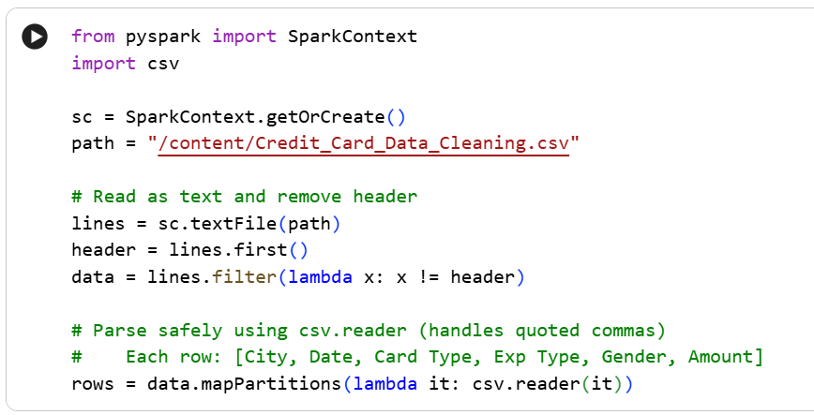 by

2) Reads and Parses CSV data ​using PySpark RDDs

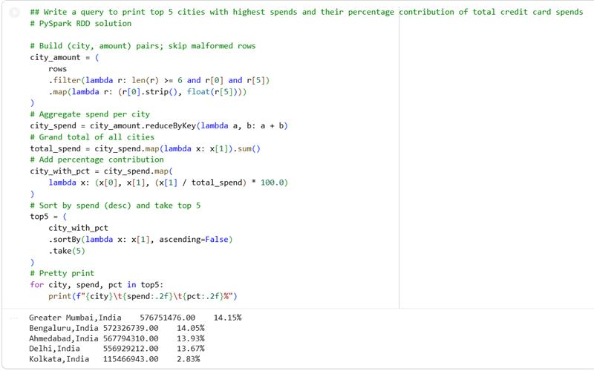
- Highest & Lowest Expense Type per City
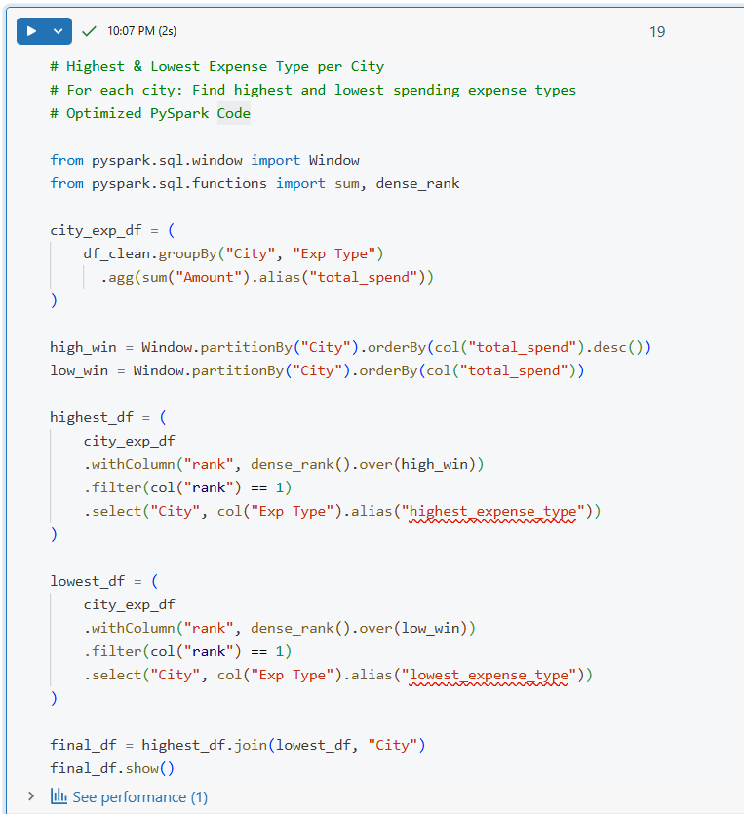output: 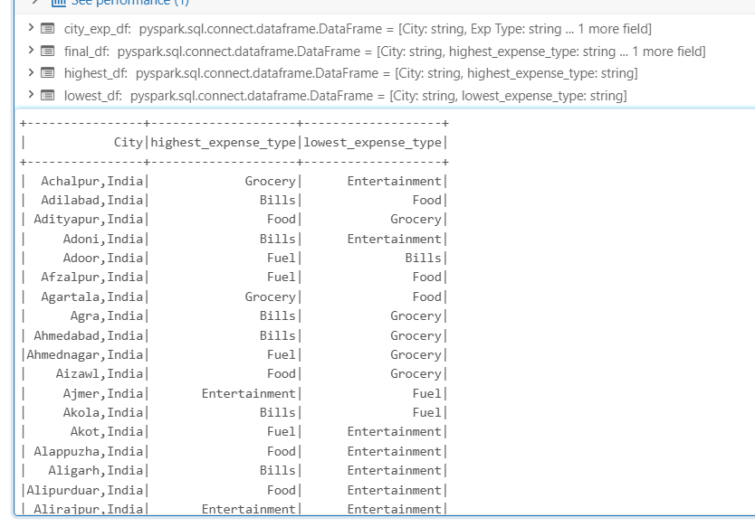
- Highest & Lowest Expense Type per City 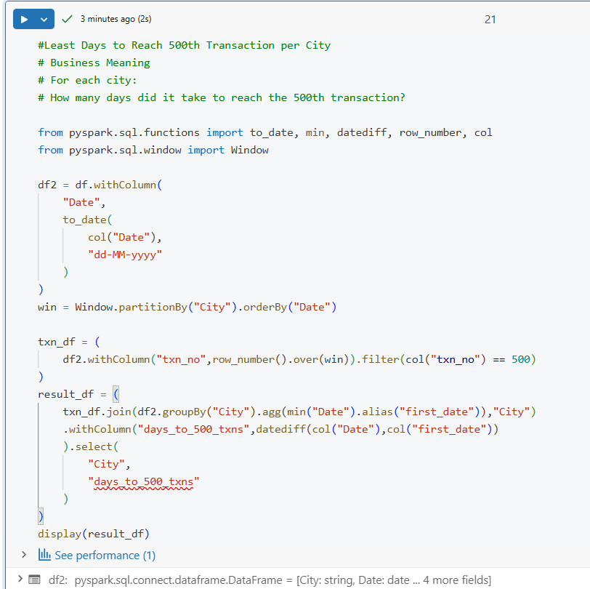output: 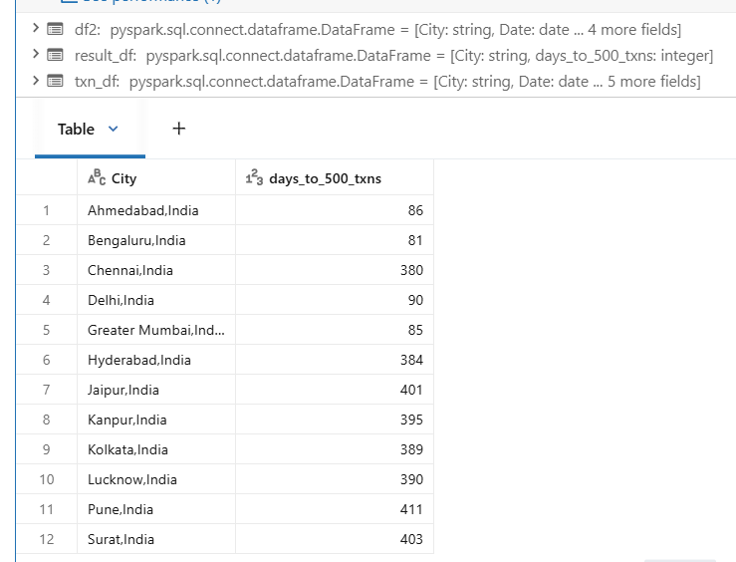

- Weekend Transaction Ratio by City
​

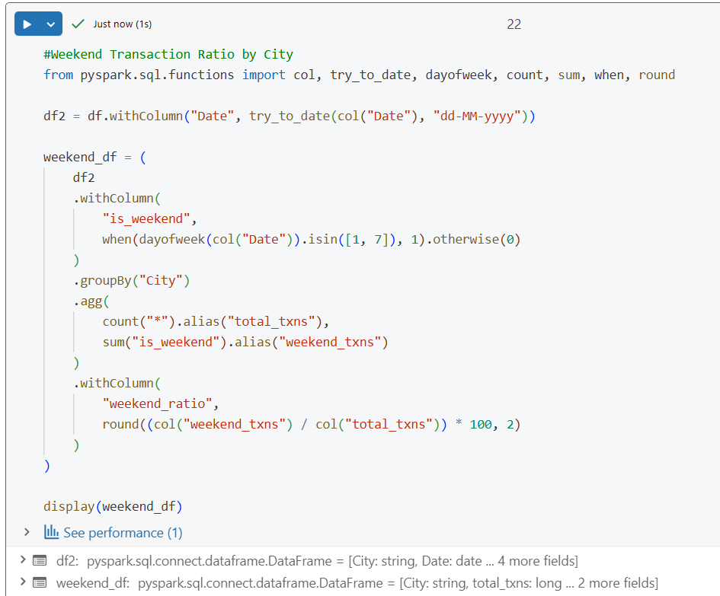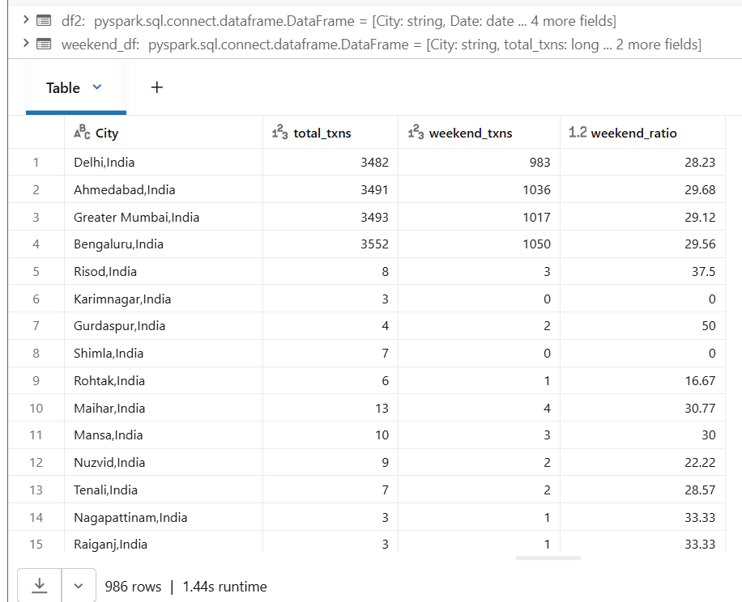
Write a PySpark query to compute, for each city the total spend and average spend based on the Amount column. Sort the result by​ total_spend in descending order and display the output.

